Issued: January 19th, 2011
Conduct: Teams of 2
Requirements: (1) Laptop computers with Internet access and a web browser
BACKGROUND
This Case Study expands your knowledge of certification requirements to an important safety system that has saved many lives: the Enhanced Ground Proximity Warning System (EGPWS). The objective is to locate the regulatory requirements for EGPWS and to understand the Intended Function of each of the EGPWS modes.
SCENARIO
Your loyal customer is back again after his successful implementation of the ADC architecture for the Piaggio Avanti. (Case 3), and he has learned that there might be a huge market for the Enhanced Ground Proximity Warning System that he plans to develop (Figure 1). Before doing so: (1) He wants to understand the marketplace, so he needs to know the regulatory obligation to install EGPWS for different sizes of aircraft; 2) He doesn’t really understand what an EGPWS is supposed to accomplish, other than helping to prevent Controlled Flight Into Terrain (CFIT) accidents; 3) He doesn’t understand the interaction between the EGPWS and the Multifunction Display (MFD), if one is installed. He has asked you to help him address these questions.
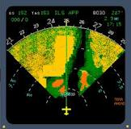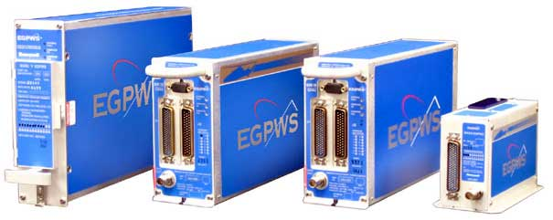
http://tinyurl.com/3swg5bw http://tinyurl.com/4y9m2ts
Figure 1 – EGPWS Display and Units

TASKS
Answer the following questions:
- Based on the CARs and advisory materials, when is an EGPWS is required?

- When must the EGPWS display on the MFD?

- What is this kind of EGPWS called?

- What does an EGPWS “Flap Override” do?

- Complete the table on the next page:

EGPWS MODE | MODE  NAME | BASIC FUNCTION
One
Two
Three
Four
Five
Six
Seven

Table 1 – Basic EGPWS Modes

